**SECURE NETWORK ARCHITECTURE**

**EX.NO.7**

**DATE: 02-04-2025 AIM:**

Learn about and implement security best practices for network environments.

**PROCEDURE:**

* Task 1 Introduction
* Task 2 Network Segmentation
* Task 3 Common Secure Network Architecture
* Task 4 Network Security Policies and Controls
* Task 5 Zone-Pair Policies and Filtering
* Task 6 Validating Network Traffic
* Task 7 Addressing Common Attacks
* Task 8 Conclusion

**Task 1 Introduction :**

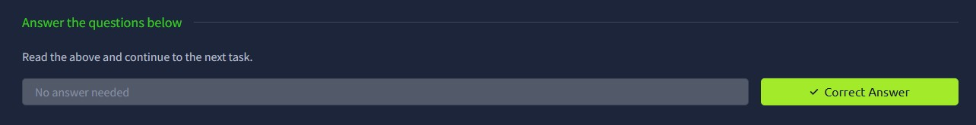

**Task 2 Network Segmentation :**

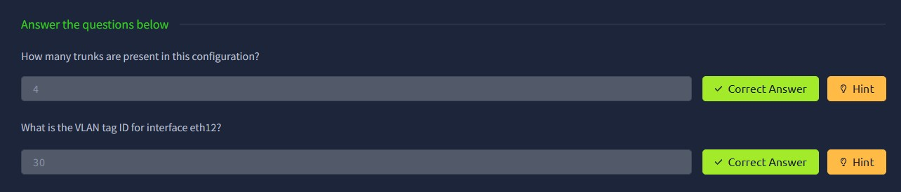

**Task 3 Common Secure Network Architecture:**

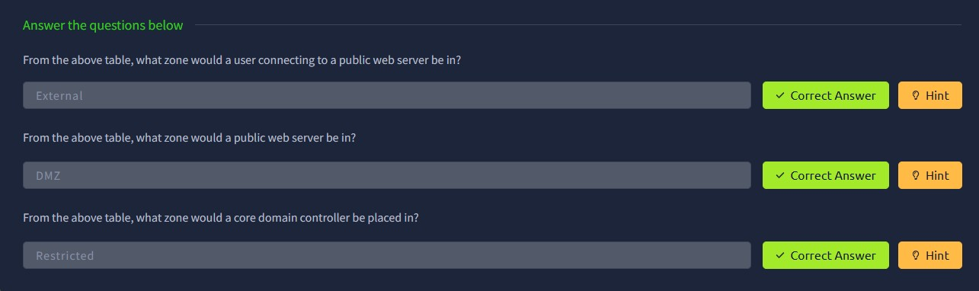

**Task 4 Network Security Policies and Controls :**

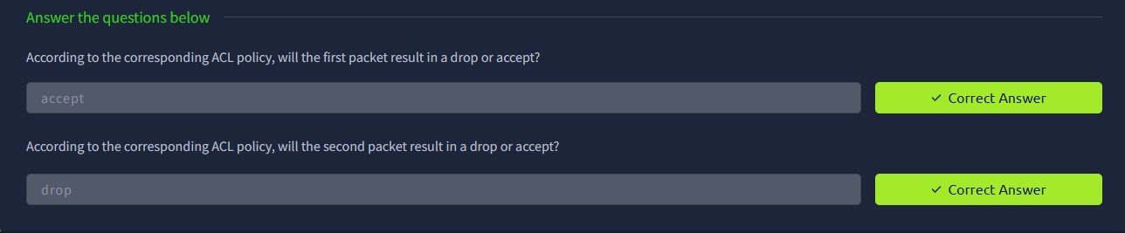

**Task 5 Zone-Pair Policies and Filtering :**

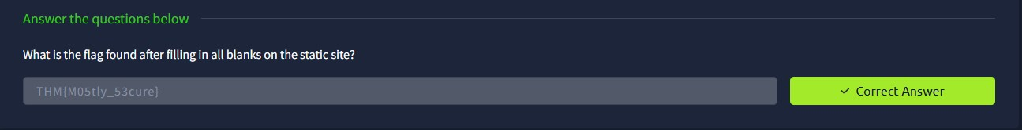

**Task 6 Validating Network Traffic :**

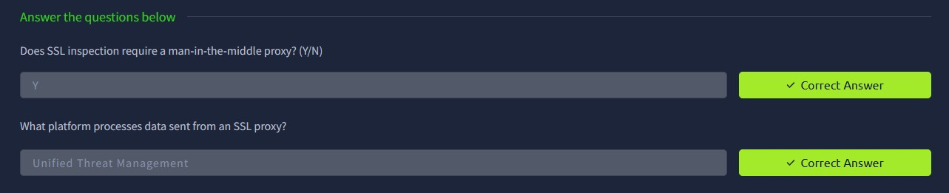

**Task 7 Addressing Common Attacks :**

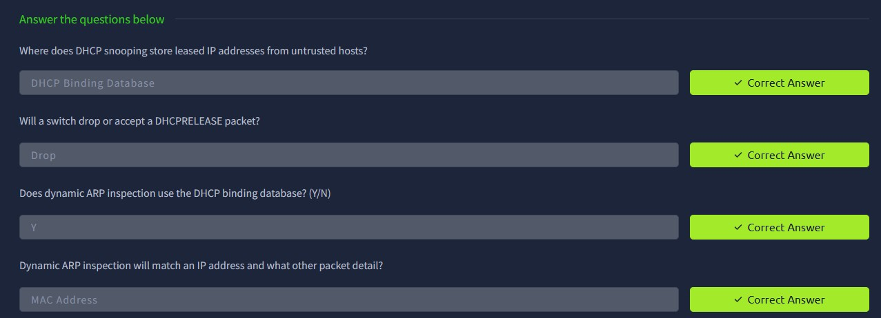

**Task 8 Conclusion :**

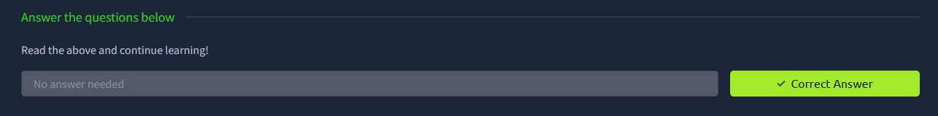

**RESULT:**

Thus, the Secure Network Architecture is completed using tryhackme platform.